Practical: AI Ethics and Governance

From the from the previous lesson we had learned about what is AI ethics and Governance. We had introduce some concept of Explainer AI methods and tool. Let look at some of these methods and tools.

Section 1: Visual Inspection – Image Classification
http://www.heatmapping.org/
Start the link in the browser, then select the following in RED
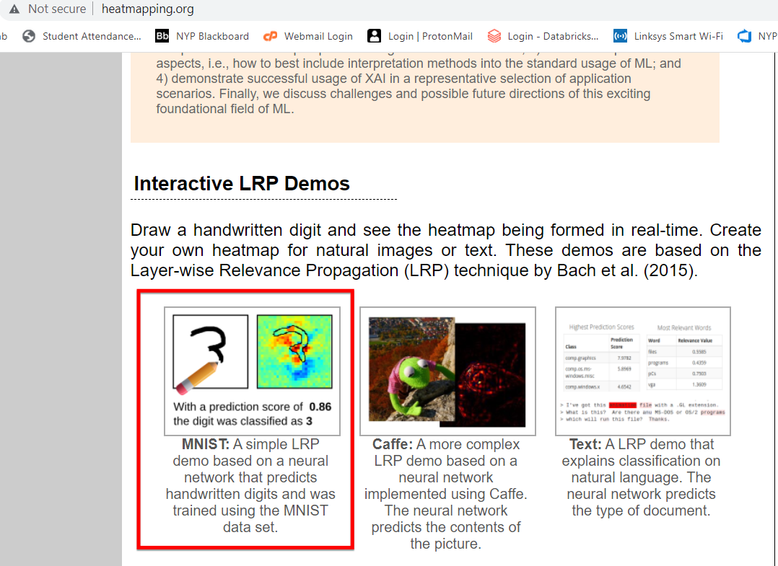

Select Handwriting Classification.
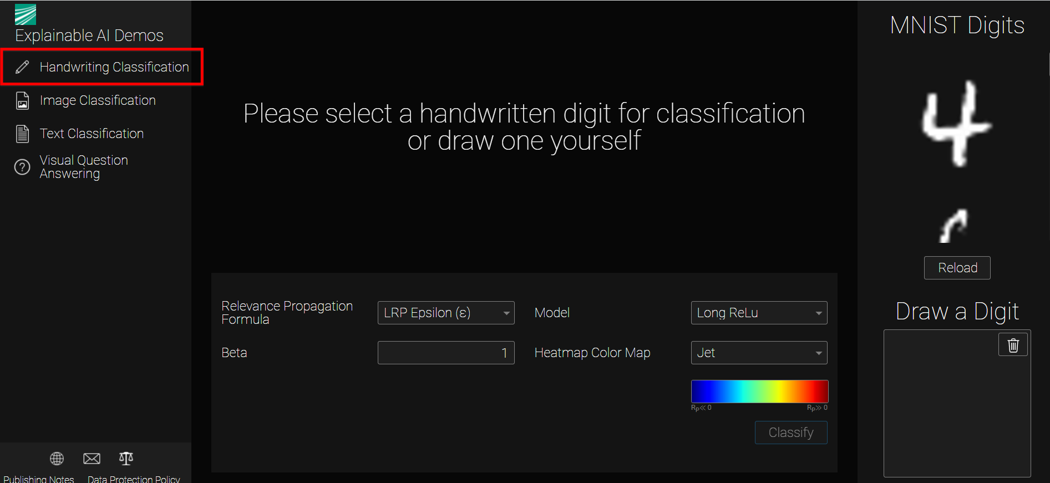

Execrise 1
Choose the number 6
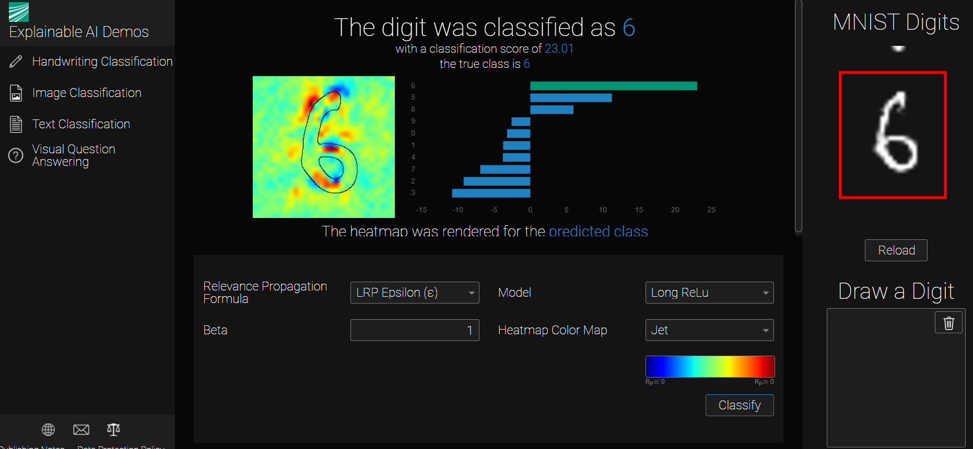

Observe the heatmap of the number 6. See the the red color location in the heatmap.
Then draw your number 6 at the box Draw a Digit. See the red color location in the heatmap.

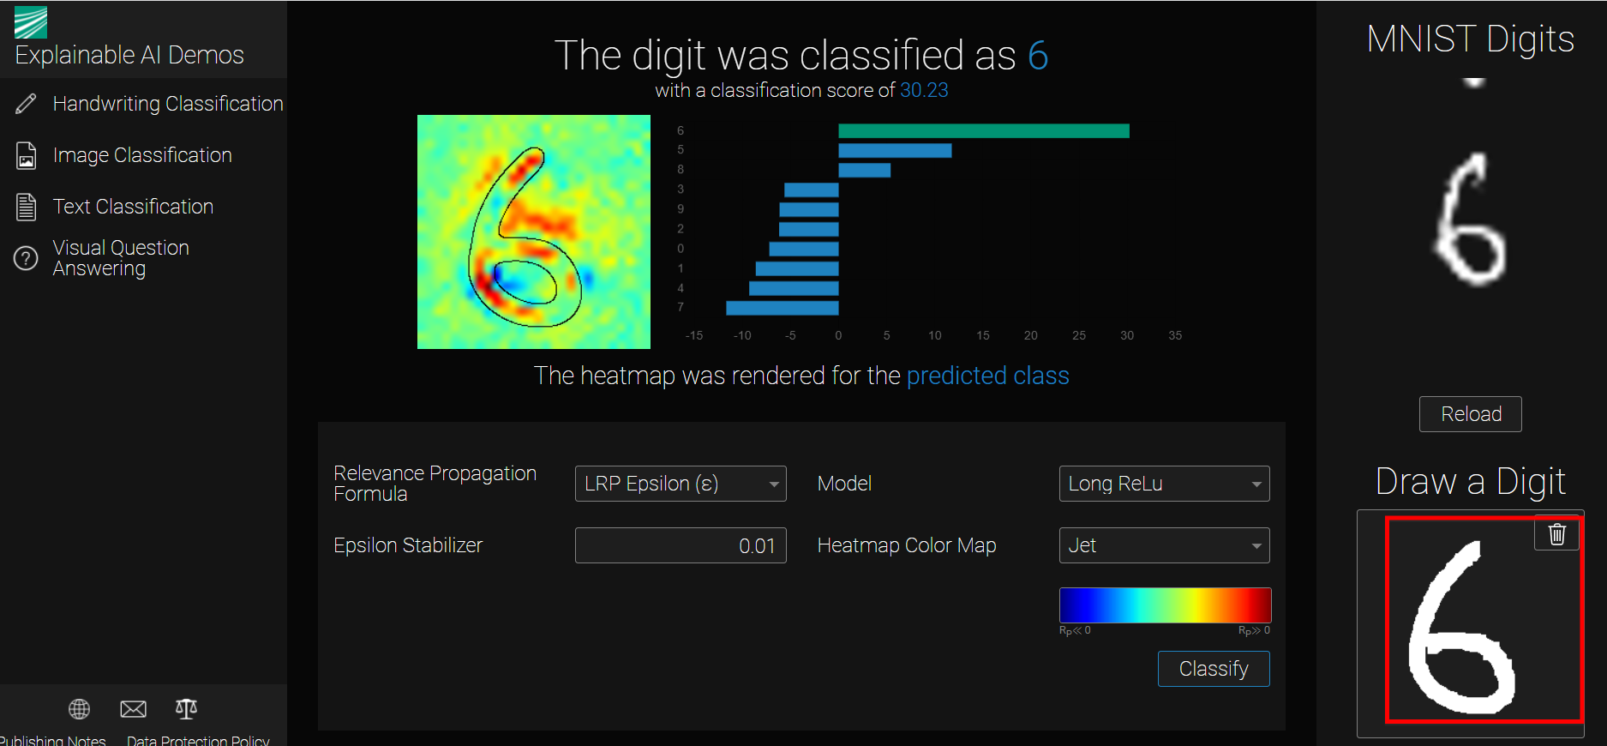

Compare the 2 heatmap for the 2 different handwriting of 6.

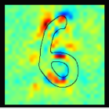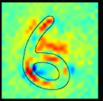
Feature 3
Feature 2
Feature 1

Both of the handwriting 6 are different images but the trained model seem using the similar features to detect the image as number 6.
Through the heatmap showing the activation points where the trained model used to predict the number 6.
In this visual display it allowed us to explain how the Deep learning model trained to predict the different handwriting image.

Try to repeat the above for different handwriting number. Identify the area of the heatmap where it used to predict the handwriting number in the image.

Execrise 2
Now try to compare the heatmap for the handwriting 2 and 7.

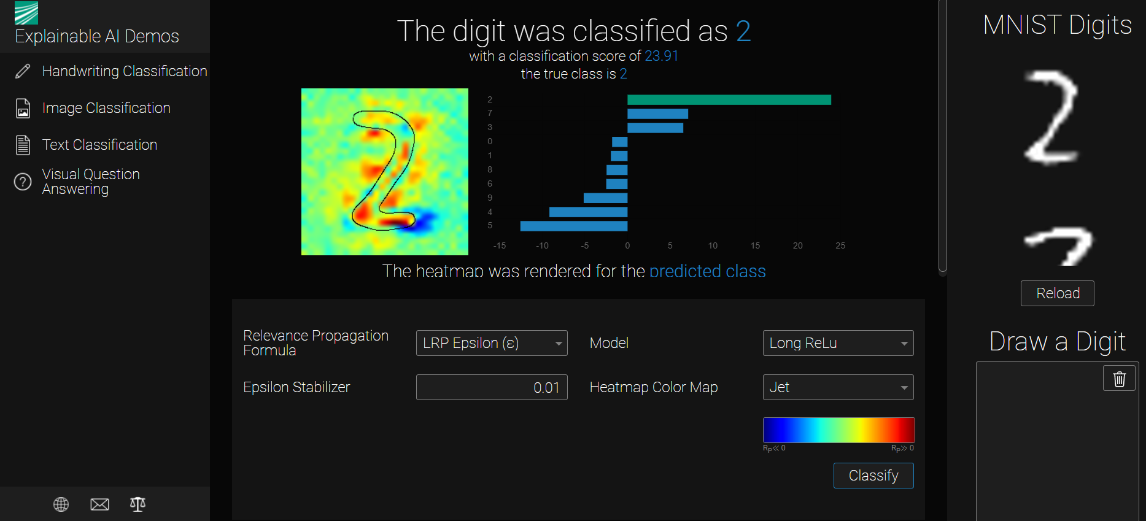
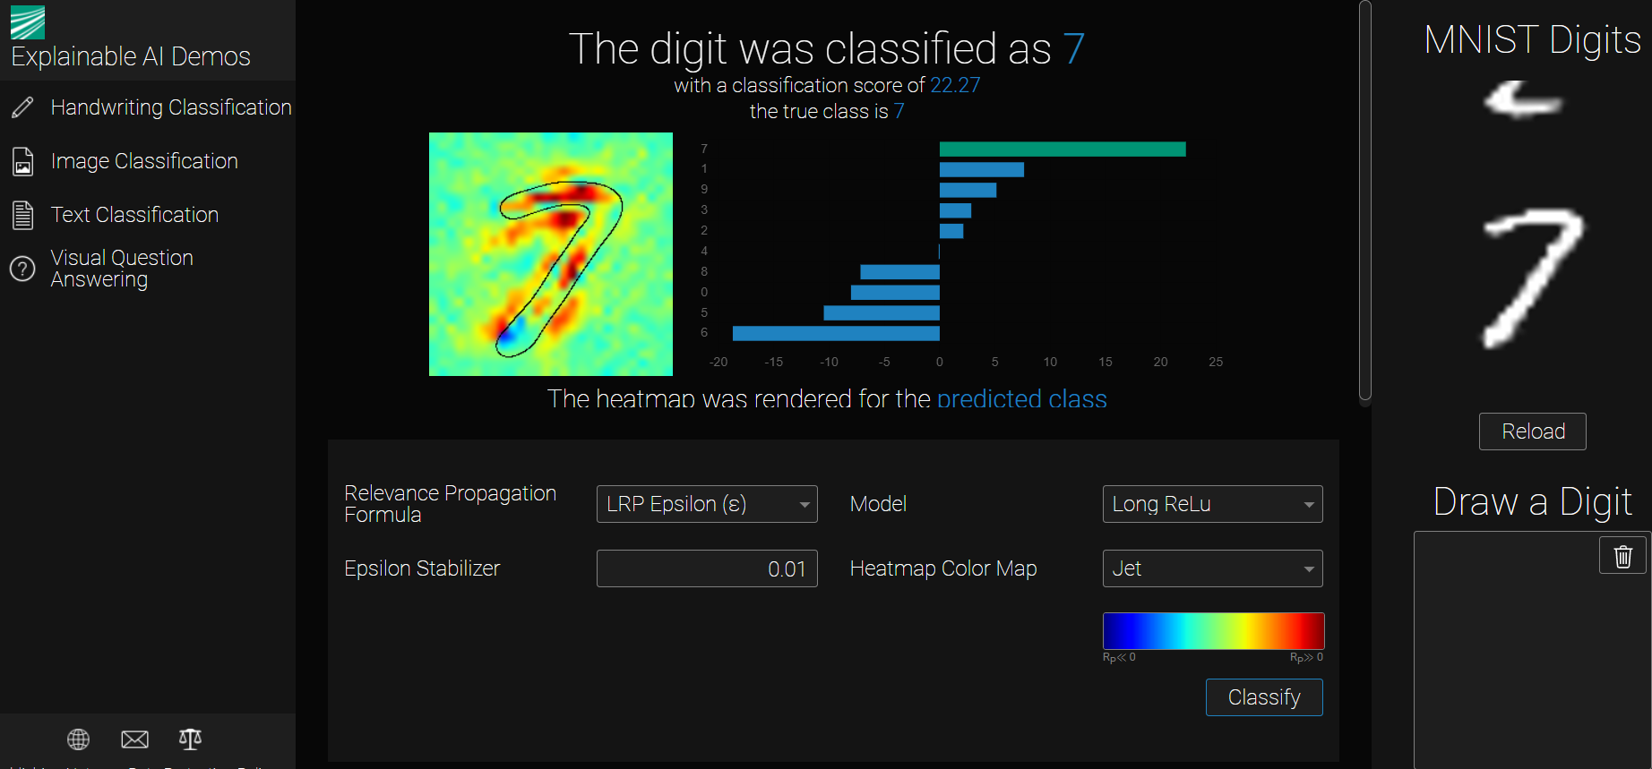
Notice both the headmap at the red region are quite similar except for the number 2. At the end there is horizontial extension to form a 2.
Try to wrote you own 2 with a shorter horzontial extension and see the heatmap and predicted result.
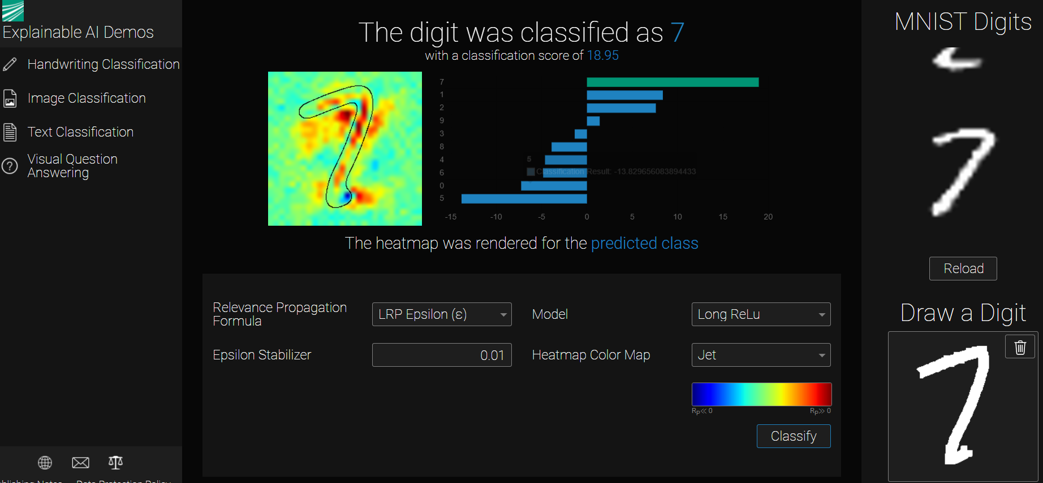
You notice the predicted result is 7 instead. How to you explain why there is an different result from the expected handwriting number 2?
We had observed most of the region that used to identify 2 and 7 are quite similar. But the important region to distinct 2 amd 7 is the horizontal line the end. In this particular handwriting number 2, the horizontial line at the end is too short to be identify are the 2, so the model is predict it to the closest number 7 based on the headmap region.

Execrise 3
Now try more complext image classification.
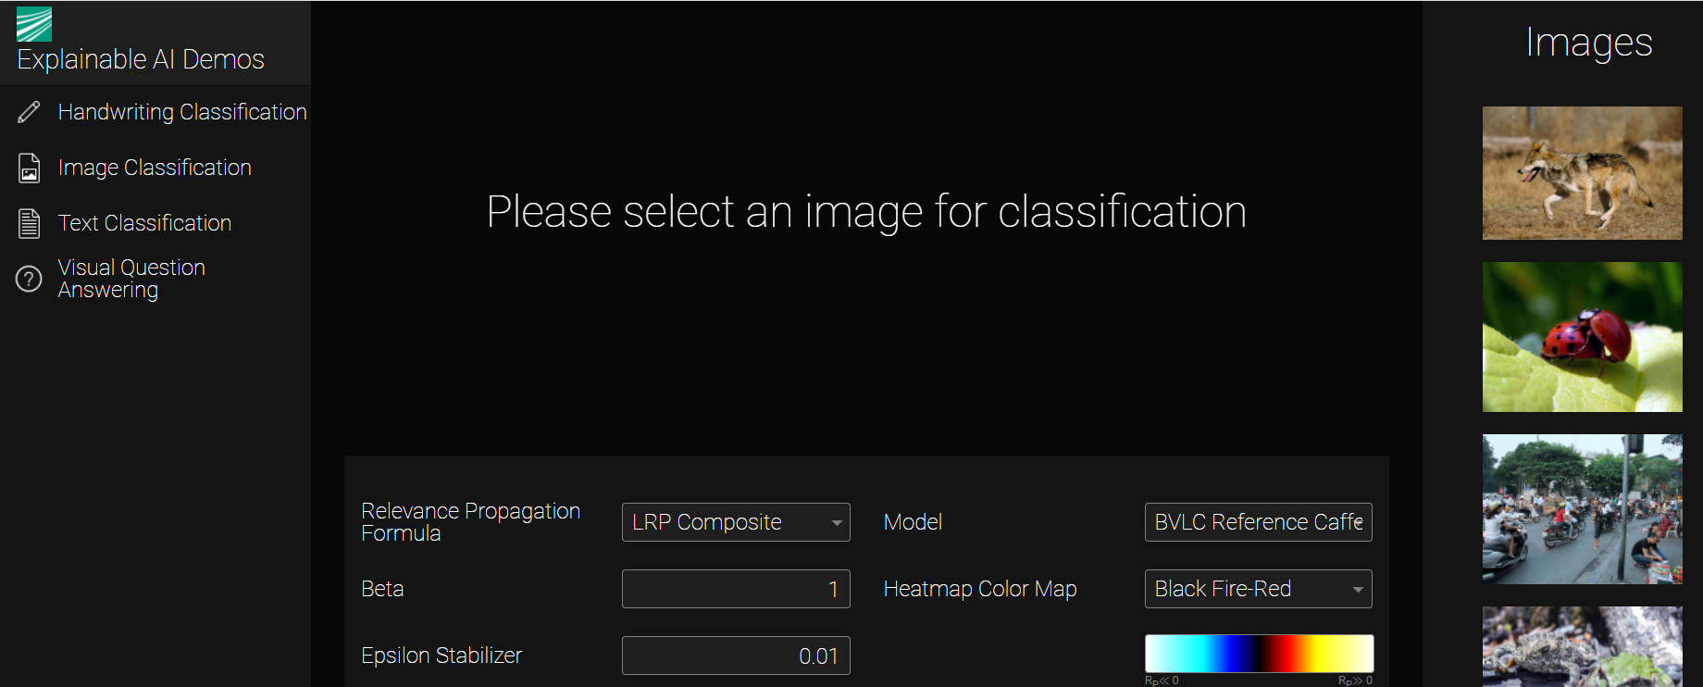

Test image with the dog1.jpg, dog2.jpg, wolf1.jpg and wolf2.jpg.

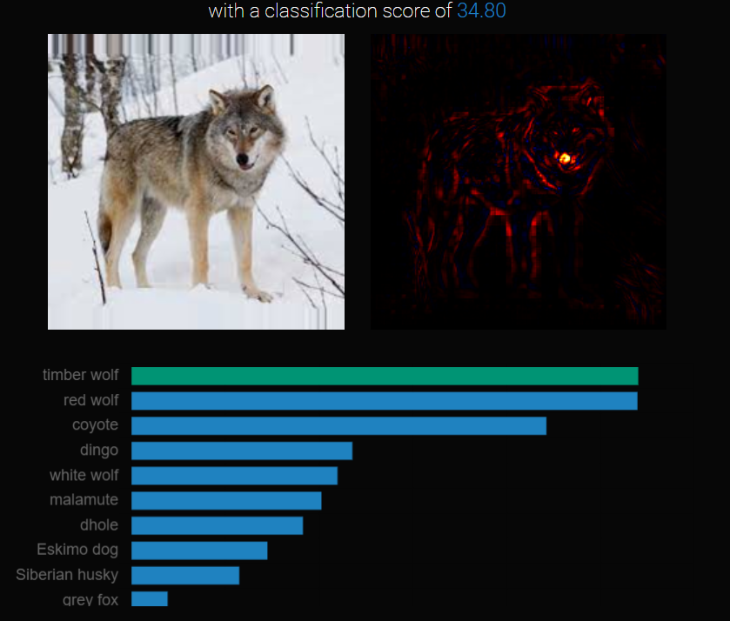
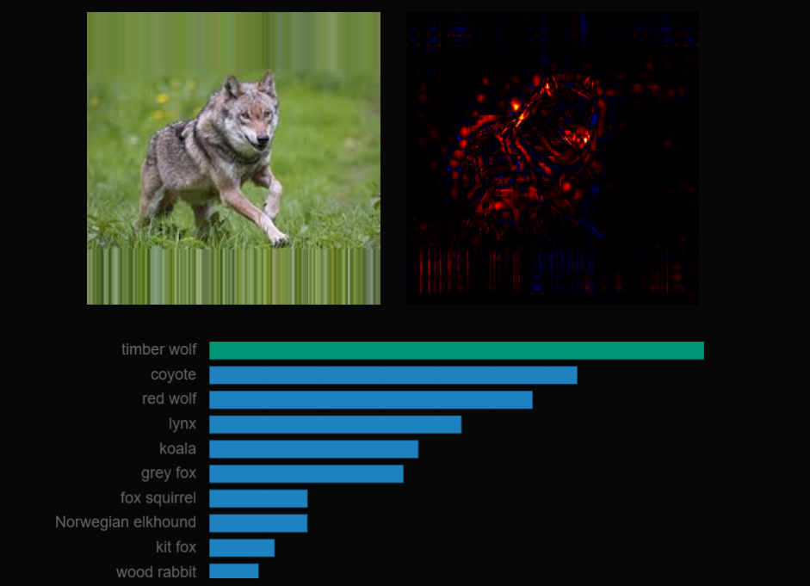

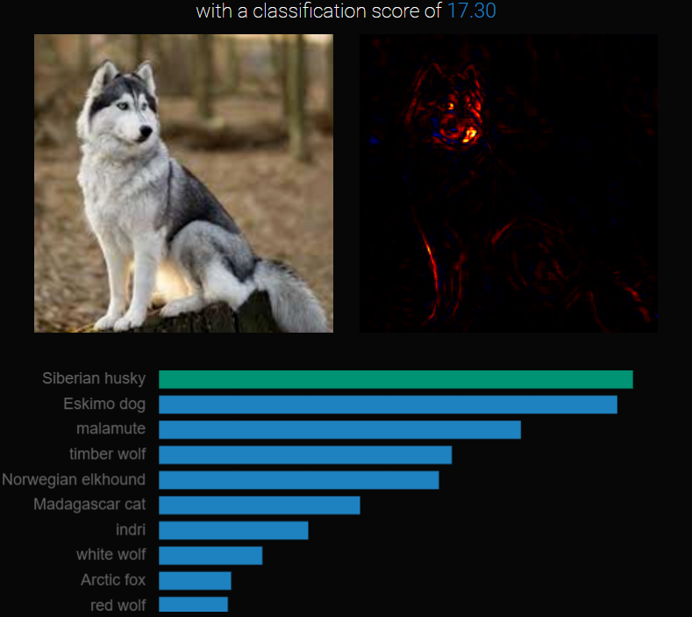
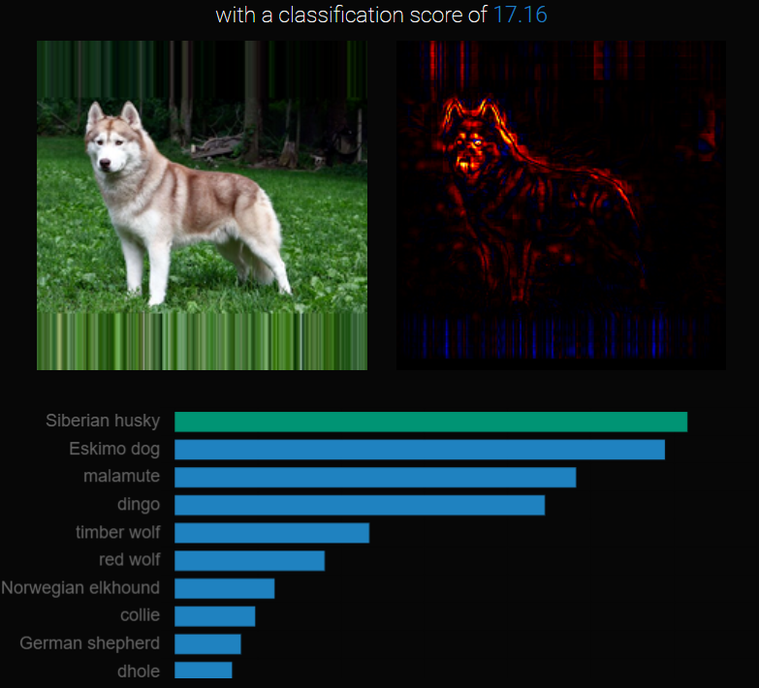
Can you explain how the model classify the 2 different type of animals?

Section 2: Visual Inspection – Text Classification
Select the Text Classification
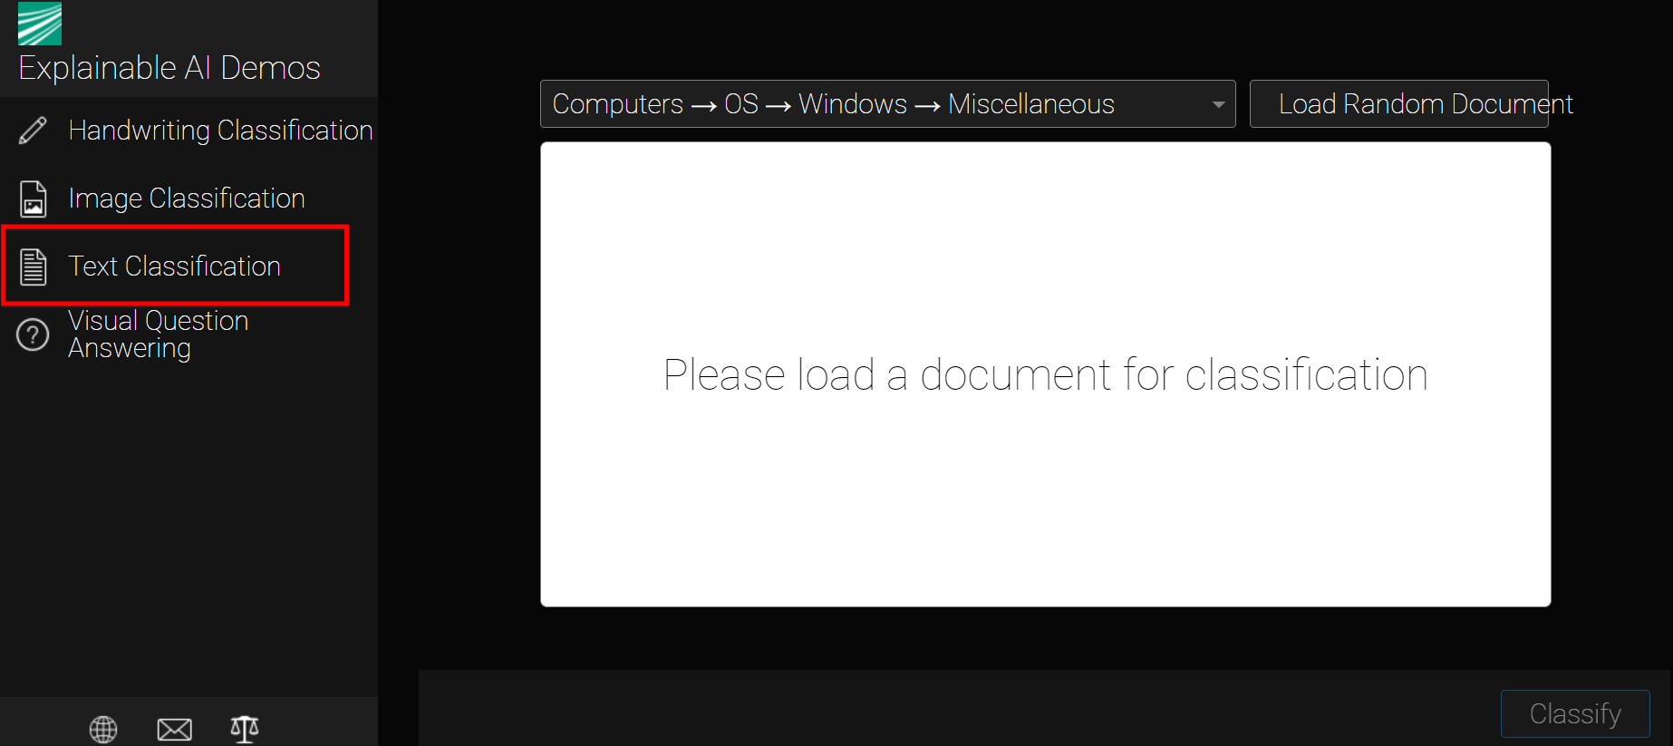
Seelct Science->Medicine , Load Random Document then Classify
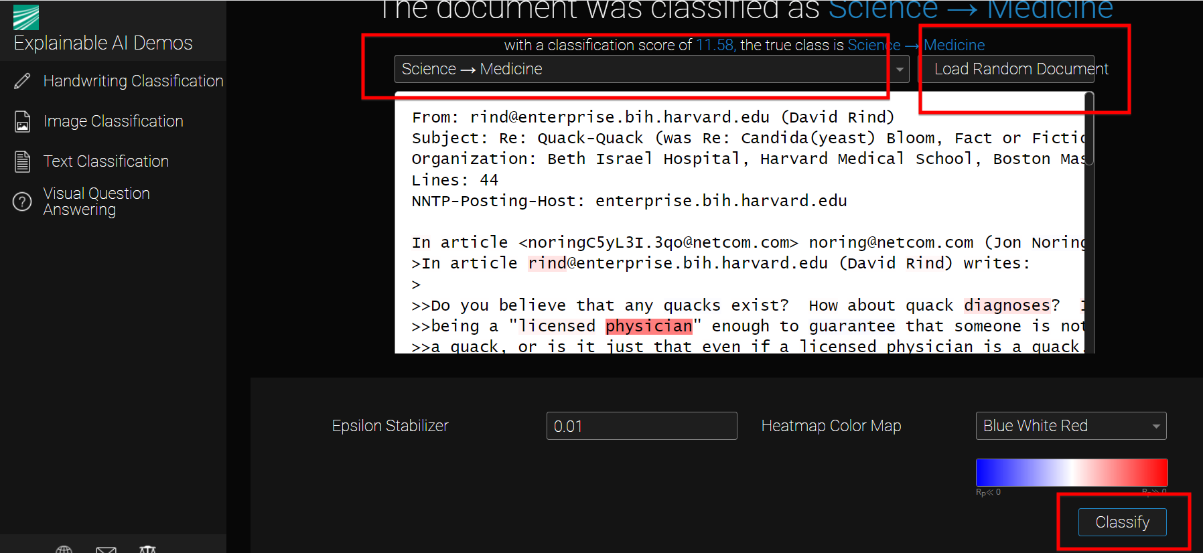
See the heightlighted word in Red to check it help to identify the topic for Science->Medicine?
Can you identify the importance words used to explain why it should be a Medicine document?

